**4. PERFORMANCE ANALYSIS**

**4.1 Algorithm Development:**

**4.1.1. System Flowchart**

A flowchart of the major functions of The Drowsy Driver Detection System is shown in Figure 4.1.

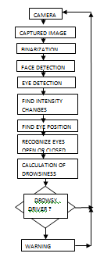

Figure4.1 Flowchart of Drowsy Driver Detection System

The function of the system can be broadly divided into eye detection function, comprising the first half of the preprocess-ing routine, and a drowsiness detection function, comprising the second half. After inputting a facial image, preprocessing is performed to binarize the image and remove noise, which makes it possible for the image to be accepted by the image processor. The maximum width of the face is then detected so that the right and left edges of the face can be identified. After that the vertical position of each eye is detected independently within an area defined by the center line of the face width and lines running through the outermost points of the face. On that basis, the area in which each eye is present is determined. Once the areas of eye presence have been defined, they can be updated by tracking the movement of the eyes. The